**Box Model**

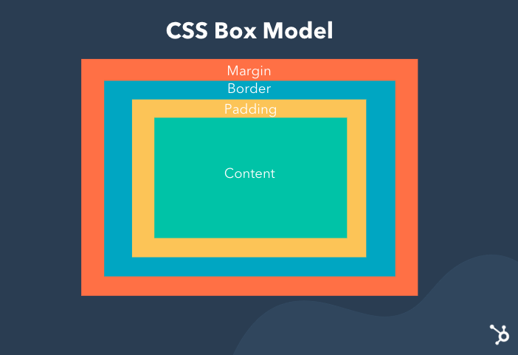

The Box Model in CSS3 is a fundamental concept that describes how elements on a web page are structured and spaced.

It's crucial for understanding how elements are sized, positioned, and spaced **relative to each other**.

The Box Model consists of four main components:

1. **Content**:

This refers to the actual content of an HTML element, such as text, images, or other media.

It's represented by the innermost part of the box.

1. **Padding**:

Padding is the space between the content of the element and its border.

It provides space inside the element, effectively increasing its size.

Padding can be set individually for each side of the element (top, right, bottom, left) using properties like **padding-top**, **padding-right**, **padding-bottom**, and **padding-left**.

Alternatively, you can use the shorthand property **padding** to set padding for all sides at once.

h1{

padding-top:10px;

padding-right:20px;

padding-bottom:15px;

padding-left:12px;

}

h1 {

padding: 10px 20px 15px 12px (t(10), r(20), b(15), l(12))

}

h1 {

padding: 10px 15px 12px (t(10), (r, l)(15), b(12))

}

h1 {

padding: 10px 20px;((t,b)(10), (l,r)(20))

}

h1 {

padding: 15px;((t,b,l,r)(15))

}

1. **Border**:

The border surrounds the padding and content of the element and defines its visible edges.

Borders can be styled in terms of width, style, and color using properties like **border-width**, **border-style**, and **border-color**.

You can also use the shorthand property **border** to set all border properties at once.

h1{

border-width:7px;

border-style:double;

border-color:green;

}

h1 {

border: 7px double green; (width style color)

}

1. **Margin**:

Margin is the space outside the border of the element, creating separation between adjacent elements.

Margin effectively defines the distance between elements on the page.

Like padding, margins can be set individually for each side of the element using properties like **margin-top**, **margin-right**, **margin-bottom**, and **margin-left**, or you can use the shorthand property **margin** to set margins for all sides at once.

In CSS3, you have more control over the Box Model with properties like **box-sizing**.

The **box-sizing** property determines how the total width and height of an element are calculated.

The default value is **content-box**, which calculates the width and height of the content area only.

However, you can set it to **border-box**, which includes padding and border in the element's total width and height calculation.

This can be particularly useful for easier layout calculations.

Understanding and effectively utilizing the Box Model in CSS3 is essential for creating well-structured and visually appealing web layouts.

It allows developers to control the spacing, positioning, and sizing of elements with precision, resulting in cohesive and visually pleasing web designs.

**border**

The border property is a shorthand syntax in CSS that accepts multiple values for drawing a line around the element it is applied to.

.belement{

border: 3px solid red;

width: 200px;

}

### Syntax

border: <line-width> || <line-style> || <color>

### Values

The border property accepts one or more of the following values in combination:

* border-width: Specifies the thickness of the border.
  + : A numeric value measured in px, em, rem, vh and vw units.
  + thin: The equivalent of 1px
  + medium: The equivalent of 3px
  + thick: The equivalent of 5px
* border-style: Specifies the type of line drawn around the element, including:
  + solid: A solid, continuous line.
  + none (default): No line is drawn.
  + hidden: A line is drawn, but not visible. this can be handy for adding a little extra width to an element without displaying a border.
  + dashed: A line that consists of dashes.
  + dotted: A line that consists of dots.
  + double: Two lines are drawn around the element.
  + groove: Adds a bevel based on the color value in a way that makes the element appear pressed into the document.
  + ridge: Similar to groove, but reverses the color values in a way that makes the element appear raised.
  + inset: Adds a split tone to the line that makes the element appear slightly depressed.
  + outset: Similar to inset, but reverses the colors in a way that makes the element appear slightly raised.
* border-color: Specifies the color of the border and accepts all valid color values.

**display**

The display property in CSS is used to define the layout behavior of an element, determining how it is displayed in the document. Here’s an overview of common display values and their purposes:

**Common Display Values**

1. **block**
   * The element starts on a new line and takes up the full width available.
   * Examples: <div>, <p>, <h1> by default.

.block {

display: block;

}

1. **inline**
   * The element does not start on a new line and only takes up as much width as necessary.
   * Examples: <span>, <a>, <strong> by default.

.inline {

display: inline;

}

1. **inline-block**
   * Combines features of inline (no line break) and block (accepts box model properties like width and height).

.inline-block {

display: inline-block;

}

1. **none**
   * The element is not displayed and does not take up any space in the layout.

.hidden {

display: none;

}

1. **flex**
   * Enables the Flexbox layout model, allowing flexible and efficient alignment and distribution of elements.
   * Example:

.flex-container {

display: flex;

}

1. **grid**
   * Enables the Grid layout model for two-dimensional layout control.

.grid-container {

display: grid;

}

1. **inline-flex**
   * Similar to flex, but behaves like an inline element.

.inline-flex {

display: inline-flex;

}

1. **inline-grid**
   * Similar to grid, but behaves like an inline element.

.inline-grid {

display: inline-grid;

}

1. **table**
   * Mimics the behavior of table elements.

.table {

display: table;

}

1. **contents**
   * The element itself is not displayed, but its children are rendered as normal.

.contents {

display: contents;

}

**Example**

Here’s a CSS example showing different display values:

<!DOCTYPE html>

<html lang="en">

<head>

<meta charset="UTF-8">

<meta name="viewport" content="width=device-width, initial-scale=1.0">

<style>

.block {

display: block;

background: lightblue;

margin: 10px 0;

}

.inline {

display: inline;

background: lightgreen;

margin: 5px;

}

.flex-container {

display: flex;

gap: 10px;

background: lightcoral;

padding: 10px;

}

.flex-item {

background: white;

padding: 10px;

border: 1px solid black;

}

</style>

<title>CSS Display</title>

</head>

<body>

<div class="block">Block Element</div>

<span class="inline">Inline Element 1</span>

<span class="inline">Inline Element 2</span>

<div class="flex-container">

<div class="flex-item">Flex Item 1</div>

<div class="flex-item">Flex Item 2</div>

<div class="flex-item">Flex Item 3</div>

</div>

</body>

</html>

**box-sizing**

The box-sizing property in CSS is used to control how the total width and height of an element is calculated.

It has two possible values:

**content-box (default):**

This value calculates an element's width and height including only the content, but not the padding, border, or margin.

In other words, the width and height specified for the element are applied to the content area only.

**border-box:**

This value includes the padding and border in the element's total width and height.

It ensures that the specified width and height also account for the padding and border, which can be very useful for layout consistency.

For example, if you set an element's width to 200px and use box-sizing: content-box, the total width may exceed 200px when you add padding and borders.

On the other hand, if you use box-sizing: border-box, the element's total width would remain 200px, and the padding and border would be included within that width.

Here's an example of how to use the box-sizing property in CSS:

.box {

width: 200px;

padding: 20px;

border: 2px solid black;

box-sizing: border-box;

}

In this example, with **box-sizing: border-box**, the total width of the .box element remains 200px, including the padding and border

**Example 01:**

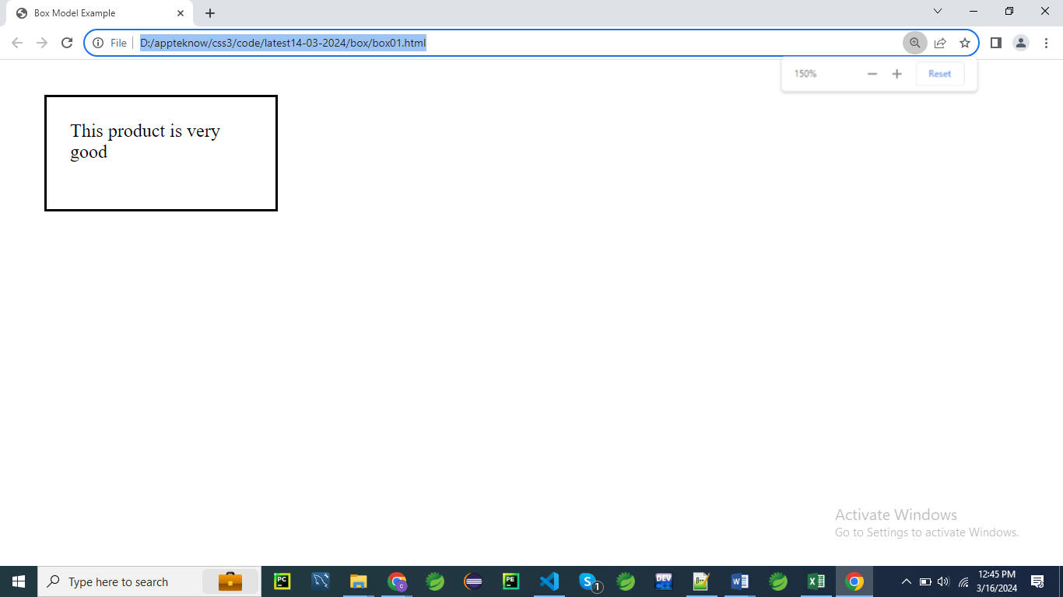

<!DOCTYPE html>

<html lang="en">

<head>

<meta charset="UTF-8">

<meta name="viewport" content="width=device-width, initial-scale=1.0">

<title>Box Model Example</title>

<style>

/* Apply CSS to demonstrate the Box Model */

.box {

width: 200px; /* Set the width of the box */

height: 100px; /* Set the height of the box */

padding: 20px; /* Add padding inside the box */

border: 2px solid black; /* Add a black border around the box */

margin: 30px; /* Add margin around the box */

box-sizing: border-box; /* Include padding and border in the width and height */

}

</style>

</head>

<body>

<div class="box">

This product is very good

</div>

</body>

</html>

**Explanation:**

**.box {**

**width: 200px;**

**height: 100px;**

**padding: 20px;**

**border: 2px solid black;**

**margin: 30px;**

**box-sizing: border-box;**

**}**

Here is a more detailed explanation of the CSS rules with 5 points each:

**.box {**

1. This targets HTML element with the class name box.
2. A class selector is used, denoted by the period (.) before the class name.
3. The rules inside this block will apply to all elements that have this class.
4. Multiple elements can share the same class name and thus the same styles.
5. This allows for consistent styling across multiple elements.

**width: 200px;**

1. Sets the width of the element to 200 pixels.
2. The width determines how wide the content area of the element will be.
3. Does not include padding, border, or margin in this width (**unless box-sizing: border-box is used**).
4. Useful for controlling the horizontal space an element occupies.
5. Helps maintain layout consistency and alignment.

**height: 100px;**

1. Sets the height of the element to 100 pixels.
2. The height determines how tall the content area of the element will be.
3. Does not include padding, border, or margin in this height (unless box-sizing: border-box is used).
4. Helps control vertical space and ensures content fits within the element.
5. Important for maintaining the overall design and layout structure.

**padding: 20px;**

1. Adds 20 pixels of space inside the element on all sides.
2. Padding is the space between the content and the border of the element.
3. Ensures content does not touch the borders, providing better readability.
4. Padding is part of the element’s box model and affects its total size.
5. Evenly applied padding ensures a balanced appearance.

**border: 2px solid black;**

1. Adds a 2-pixel-wide border around the element.
2. The border style is solid, meaning it’s a continuous line.
3. The border color is black.
4. Borders help define the boundaries of an element and can enhance its appearance.
5. Borders are included in the total width and height of the element when **box-sizing: border-box** is used.

**margin: 30px;**

1. Adds 30 pixels of space outside the element on all sides.
2. Margin creates space between the element and other elements around it.
3. Margins do not affect the size of the element itself.
4. Useful for positioning and separating elements.
5. Helps prevent elements from overlapping or being too close to each other.

**box-sizing: border-box;**

1. Changes the box model calculation for the element.
2. Includes padding and border in the specified width and height.
3. Ensures the total size of the element is consistent with the specified dimensions.
4. Helps avoid unexpected layout issues caused by adding padding and borders.
5. Simplifies size calculations and helps maintain design consistency

**In this example**:

* We have a **<div>** element with the class "box", which we're using to demonstrate the Box Model.
* We apply CSS styles to the **.box** class to set its width, height, padding, border, margin, and **box-sizing**.
* The width and height properties set the dimensions of the box itself.
* Padding provides space inside the box, and we've set it to 20 pixels on all sides.
* The border property adds a black border around the box, with a thickness of 2 pixels.
* Margin adds spacing around the box, and we've set it to 30 pixels on all sides.
* We use **box-sizing: border-box;** to ensure that the width and height we specify include padding and border, making layout calculations simpler and more predictable.

**Example 02:**

___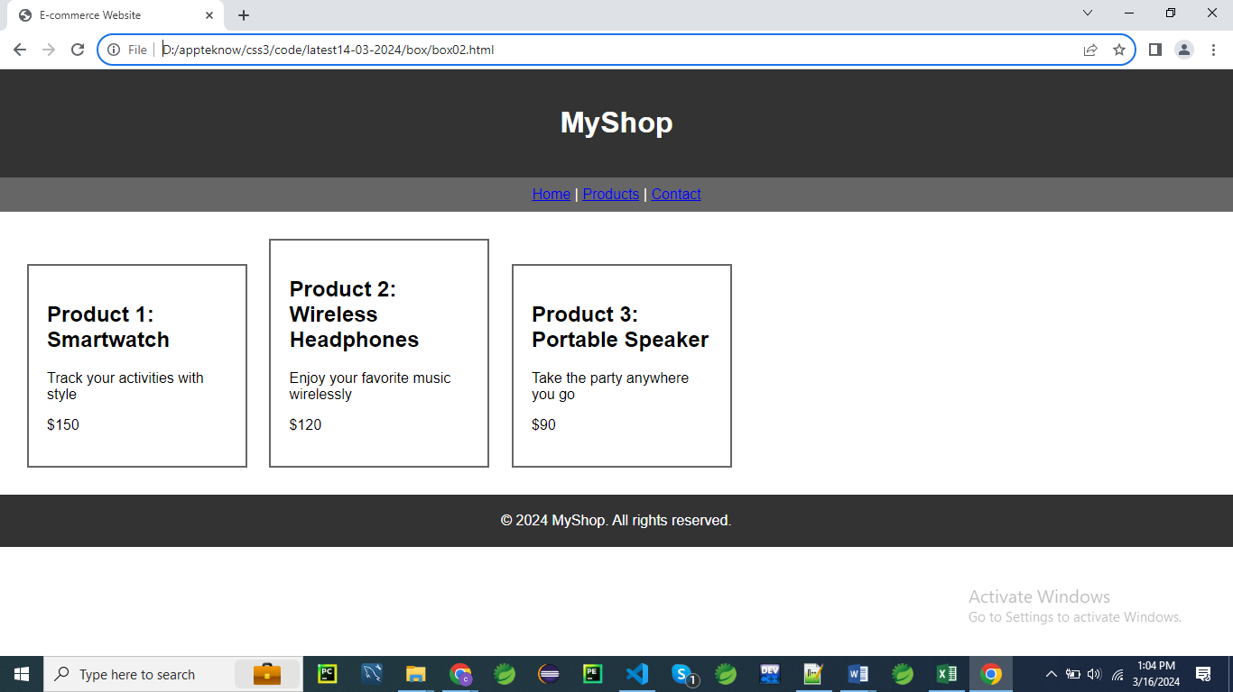

<!DOCTYPE html>

<html lang="en">

<head>

<meta charset="UTF-8">

<meta name="viewport" content="width=device-width, initial-scale=1.0">

<title>E-commerce Website</title>

<style>

    /* Apply CSS to create a simple e-commerce website layout with explanations of the Box Model */

    body {

        font-family: Arial, sans-serif;

        margin: 0;

        padding: 0;

    }

    header {

        background-color: #333;

        color: #fff;

        padding: 20px; /* Padding: Provides space inside the box */

        text-align: center;

    }

    nav {

        background-color: #666;

        color: #fff;

        padding: 10px; /* Padding: Provides space inside the box */

        text-align: center;

    }

    section {

        padding: 20px; /* Padding: Provides space inside the box */

    }

    .product {

        border: 2px solid #666; /* Border: Surrounds the content and padding */

        margin: 10px; /* Margin: Creates space outside the box */

        padding: 20px; /* Padding: Provides space inside the box */

        display: inline-block;

        width: 200px; /* Set width of product box */

    }

    footer {

        background-color: #333;

        color: #fff;

        padding: 20px; /* Padding: Provides space inside the box */

        text-align: center;

    }

</style>

</head>

<body>

    <header>

        <h1>MyShop</h1>

    </header>

    <nav>

        <a href="#">Home</a> |

        <a href="#">Products</a> |

        <a href="#">Contact</a>

    </nav>

    <section>

        <div class="product">

            <h2>Product 1: Smartwatch</h2>

            <p>Track your activities with style</p>

            <p>$150</p>

        </div>

        <div class="product">

            <h2>Product 2: Wireless Headphones</h2>

            <p>Enjoy your favorite music wirelessly</p>

            <p>$120</p>

        </div>

        <div class="product">

            <h2>Product 3: Portable Speaker</h2>

            <p>Take the party anywhere you go</p>

            <p>$90</p>

        </div>

    </section>

    <footer>

        &copy; 2024 MyShop. All rights reserved.

    </footer>

</body>

</html>

**Explanation:**

**body {**

**font-family: Arial, sans-serif;**

**margin: 0;**

**padding: 0;**

**}**

**body {**

1. This targets the body element in an HTML document.
2. The body element represents the content of the document.
3. All visible content is typically placed inside the body element.
4. Styles applied to the body element affect the entire page.
5. It's a block-level element and the primary container for content.

**font-family: Arial, sans-serif;**

1. Sets the font family for the text in the document to Arial.
2. Arial is a widely used, sans-serif typeface, meaning it lacks the small decorative lines at the end of characters.
3. sans-serif is a generic font family, used as a fallback if Arial is unavailable.
4. This ensures a consistent and clean look for text across different browsers and devices.
5. Multiple font families can be specified, with the browser using the first available one.

**margin: 0;**

1. Removes the default margin around the body element.
2. Margins are the space outside an element's border.
3. By setting the margin to 0, the content starts from the very edge of the page.
4. Helps create a consistent starting point for the layout.
5. Prevents unexpected white space around the document content.

**padding: 0;**

1. Removes the default padding inside the body element.
2. Padding is the space between the content and the border of an element.
3. Setting padding to 0 ensures the content fills the entire space without extra padding.
4. Helps create a uniform layout starting point.
5. Prevents unexpected white space inside the document content.

**}**

1. This closes the body style rule.
2. It signifies the end of the CSS properties for the body element.
3. Ensures proper syntax and structure in the CSS code.
4. Helps keep the code organized and readable.
5. Necessary for correctly applying the defined styles to the body element.

**header {**

**background-color: #333;**

**color: #fff;**

**padding: 20px; /* Padding: Provides space inside the box */**

**text-align: center;**

**}**

**header {**

1. This targets the header element in an HTML document.
2. The header element typically contains introductory content or navigational links.
3. It's a block-level element that usually appears at the top of the document or section.
4. Styles applied to the header element affect all its content.
5. It's used to group heading and introductory information for a document or section.

**background-color: #333;**

1. Sets the background color of the header element to #333.
2. #333 is a dark gray color in hexadecimal format.
3. The background color covers the entire header element.
4. Provides a dark backdrop for the header's content, enhancing visibility and contrast.
5. Ensures a consistent look across different devices and browsers.

**color: #fff;**

1. Sets the text color of the header element to #fff.
2. #fff is white in hexadecimal format.
3. White text contrasts well with the dark background, ensuring readability.
4. Applies to all text within the header element.
5. Helps create a visually appealing and accessible design.

**padding: 20px;**

1. Adds 20 pixels of padding inside the header element on all sides.
2. Padding is the space between the content and the border of the element.
3. Ensures that the content does not touch the edges of the header, improving readability.
4. Creates a balanced and aesthetically pleasing appearance.
5. Padding is part of the element’s box model and affects its total size.

**text-align: center;**

1. Centers the text horizontally within the header element.
2. Applies to all inline content, such as text and inline-block elements.
3. Helps create a balanced and organized look for the header.
4. Ensures that the content is aligned centrally, which can be visually appealing.
5. Useful for headers where central alignment of the content is desired for symmetry.

**nav {**

**background-color: #666;**

**color: #fff;**

**padding: 10px; /* Padding: Provides space inside the box */**

**text-align: center;**

**}**

**nav {**

1. This targets the nav element in an HTML document.
2. The nav element typically contains navigation links for the site.
3. It's a block-level element that usually appears at the top, side, or bottom of a document.
4. Styles applied to the nav element affect all its content.
5. It's used to group navigational links for better organization and accessibility.

**background-color: #666;**

1. Sets the background color of the nav element to #666.
2. #666 is a medium gray color in hexadecimal format.
3. The background color covers the entire nav element.
4. Provides a neutral backdrop for the navigation content, enhancing visibility.
5. Ensures a consistent look across different devices and browsers.

**color: #fff;**

1. Sets the text color of the nav element to #fff.
2. #fff is white in hexadecimal format.
3. White text contrasts well with the medium gray background, ensuring readability.
4. Applies to all text within the nav element.
5. Helps create a visually appealing and accessible design.

**padding: 10px;**

1. Adds 10 pixels of padding inside the nav element on all sides.
2. Padding is the space between the content and the border of the element.
3. Ensures that the content does not touch the edges of the nav, improving readability.
4. Creates a balanced and aesthetically pleasing appearance.
5. Padding is part of the element’s box model and affects its total size.

**text-align: center;**

1. Centers the text horizontally within the nav element.
2. Applies to all inline content, such as text and inline-block elements.
3. Helps create a balanced and organized look for the navigation links.
4. Ensures that the content is aligned centrally, which can be visually appealing.
5. Useful for navigation bars where central alignment of the content is desired for symmetry.

**.product {**

**border: 2px solid #666; /* Border: Surrounds the content and padding */**

**margin: 10px; /* Margin: Creates space outside the box */**

**padding: 20px; /* Padding: Provides space inside the box */**

**display: inline-block;**

**width: 200px; /* Set width of product box */**

**}**

**Explanation:**

**.product:**

1. This targets the .**product** class in an HTML document.
2. The .**product** class is typically used to style individual product items.
3. It can be applied to any HTML element by adding **class="product"** to the element.
4. Styles applied to the .**product** class affect all elements with this class.
5. It's used to create a consistent and visually appealing layout for product items.

**border: 2px solid #666;:**

1. Sets a **border** around the .**product** element.
2. The **border** is **2 pixels thick**, providing a clear visual boundary.
3. The border is **solid**, meaning it’s a continuous line without any breaks.
4. The border **color is #666**, a medium gray in hexadecimal format.
5. The border surrounds the content and padding of the element, contributing to its visual appearance and size.

**margin: 10px;:**

1. Sets the margin around the .product element.
2. The margin is 10 pixels on all sides, creating space outside the element.
3. Margin separates the .product element from other elements, improving layout spacing.
4. Helps control the positioning of the element within its container.
5. Margin is not included in the element's width or height, as it creates space outside the border.

**padding: 20px;:**

1. Adds 20 pixels of padding inside the .product element on all sides.
2. Padding creates space between the content and the border of the element.
3. Ensures that the content does not touch the edges of the .product element, improving readability.
4. Padding is included in the element's total width and height, as it adds space inside the border.
5. Creates a balanced and aesthetically pleasing appearance by providing internal spacing.

**display: inline-block;:**

1. Sets the display property of the .product element to inline-block.
2. The element is treated as an inline element, but it can have width and height like a block element.
3. Allows the .product element to sit inline with other elements, but maintain block-level properties.
4. Provides more control over the element's spacing and dimensions compared to purely inline elements.
5. Useful for creating grid-like layouts without using floating elements, enabling flexible positioning.

**width: 200px;:**

1. Sets the width of the .product element to 200 pixels.
2. Ensures that the product box has a consistent width across different devices.
3. Controls the amount of content that can fit within the product box, maintaining a uniform size.
4. Helps maintain a consistent layout by setting a fixed width for product items.
5. While the width is fixed, it can be used in conjunction with media queries to adapt to different screen sizes

**footer {**

**background-color: #333;**

**color: #fff;**

**padding: 20px; /* Padding: Provides space inside the box */**

**text-align: center;**

**}**

**Explanation:**

**footer:**

1. This targets the footer element in an HTML document.
2. The footer element typically contains information such as copyright, contact details, and links.
3. It's a block-level element that usually appears at the bottom of a document.
4. Styles applied to the footer element affect all its content.
5. It's used to group footer content for better organization and accessibility.

**background-color: #333;:**

1. Sets the background color of the footer element to #333.
2. #333 is a dark gray color in hexadecimal format.
3. The background color covers the entire footer element.
4. Provides a consistent and visually appealing background for the footer content.
5. Ensures a consistent look across different devices and browsers.

**color: #fff;:**

1. Sets the text color of the footer element to #fff.
2. #fff is white in hexadecimal format.
3. White text contrasts well with the dark gray background, ensuring readability.
4. Applies to all text within the footer element.
5. Helps create a visually appealing and accessible design.

**padding: 20px;:**

1. Adds 20 pixels of padding inside the footer element on all sides.
2. Padding is the space between the content and the border of the element.
3. Ensures that the content does not touch the edges of the footer, improving readability.
4. Creates a balanced and aesthetically pleasing appearance.
5. Padding is part of the element’s box model and affects its total size.

**text-align: center;:**

1. Centers the text horizontally within the footer element.
2. Applies to all inline content, such as text and inline-block elements.
3. Helps create a balanced and organized look for the footer content.
4. Ensures that the content is aligned centrally, which can be visually appealing.
5. Useful for footers where central alignment of the content is desired for symmetry.

**Example 03**

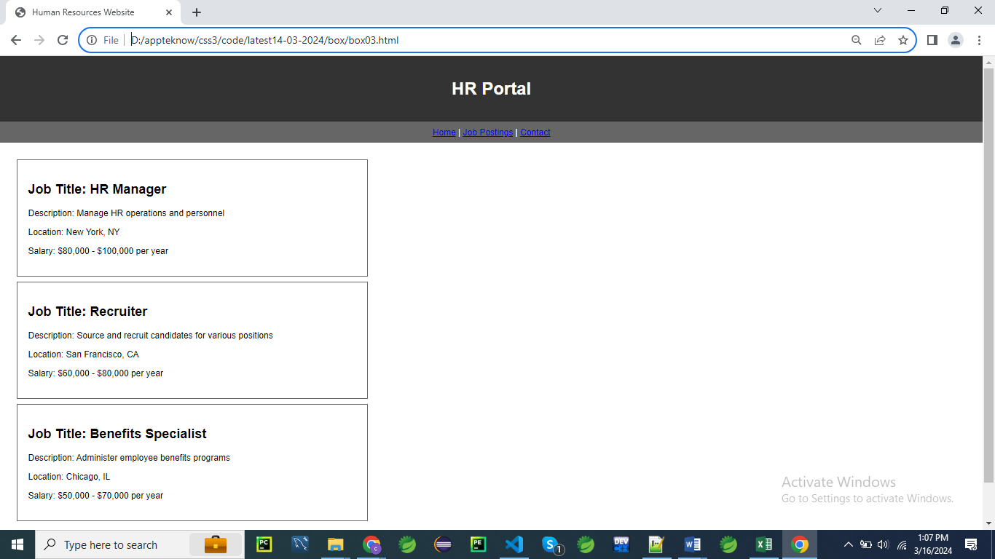

<!DOCTYPE html>

<html lang="en">

<head>

<meta charset="UTF-8">

<meta name="viewport" content="width=device-width, initial-scale=1.0">

<title>Human Resources Website</title>

<style>

    body {

        font-family: Arial, sans-serif;

        margin: 0;

        padding: 0;

    }

    header {

        background-color: #333;

        color: #fff;

        padding: 20px; /* Padding: Provides space inside the box */

        text-align: center;

    }

    nav {

        background-color: #666;

        color: #fff;

        padding: 10px; /* Padding: Provides space inside the box */

        text-align: center;

    }

    section {

        padding: 20px; /* Padding: Provides space inside the box */

    }

    .job-posting {

        border: 2px solid #666; /* Border: Surrounds the content and padding */

        margin: 10px; /* Margin: Creates space outside the box */

        padding: 20px; /* Padding: Provides space inside the box */

        width: 600px; /* Set width of job posting box */

    }

    footer {

        background-color: #333;

        color: #fff;

        padding: 20px; /* Padding: Provides space inside the box */

        text-align: center;

    }

</style>

</head>

<body>

    <header>

        <h1>HR Portal</h1>

    </header>

    <nav>

        <a href="#">Home</a> |

        <a href="#">Job Postings</a> |

        <a href="#">Contact</a>

    </nav>

    <section>

        <div class="job-posting">

            <h2>Job Title: HR Manager</h2>

            <p>Description: Manage HR operations and personnel</p>

            <p>Location: New York, NY</p>

            <p>Salary: $80,000 - $100,000 per year</p>

        </div>

        <div class="job-posting">

            <h2>Job Title: Recruiter</h2>

            <p>Description: Source and recruit candidates for various positions</p>

            <p>Location: San Francisco, CA</p>

            <p>Salary: $60,000 - $80,000 per year</p>

        </div>

        <div class="job-posting">

            <h2>Job Title: Benefits Specialist</h2>

            <p>Description: Administer employee benefits programs</p>

            <p>Location: Chicago, IL</p>

            <p>Salary: $50,000 - $70,000 per year</p>

        </div>

    </section>

    <footer>

        &copy; 2024 HR Portal. All rights reserved.

    </footer>

</body>

</html>

**CSS Rules Explanation**

**body:**

**body {**

**font-family: Arial, sans-serif;**

**margin: 0;**

**padding: 0;**

**}**

1. **font-family: Arial, sans-serif;**
   * Sets the font family for the entire body of the document.
   * Uses Arial as the primary font.
   * Falls back to a generic sans-serif font if Arial is unavailable.
   * Ensures a consistent text appearance across different devices and browsers.
   * Affects all text content within the body.
2. **margin: 0;**
   * Removes any default margin around the body element.
   * Ensures there is no extra space outside the body content.
   * Helps in achieving a full-width layout without unwanted space.
   * Sets a clean edge for the body content.
   * Provides a consistent starting point for layout adjustments.
3. **padding: 0;**
   * Removes any default padding inside the body element.
   * Ensures there is no extra space inside the body content.
   * Sets a clean edge for the body content.
   * Helps in achieving a full-width layout without unwanted space.
   * Provides a consistent starting point for layout adjustments.

**header:**

**header {**

**background-color: #333;**

**color: #fff;**

**padding: 20px; /* Padding: Provides space inside the box */**

**text-align: center;**

**}**

1. **background-color: #333;**
   * Sets the background color of the header to #333.
   * #333 is a dark gray color.
   * Covers the entire header area.
   * Provides a distinct background that contrasts with text.
   * Ensures a consistent appearance across devices and browsers.
2. **color: #fff;**
   * Sets the text color within the header to #fff.
   * #fff is white in hexadecimal format.
   * Provides high contrast with the dark gray background.
   * Enhances readability of text in the header.
   * Applies to all text within the header.
3. **padding: 20px;**
   * Adds 20 pixels of padding inside the header on all sides.
   * Creates space between the content and the border of the header.
   * Prevents text from touching the edges, improving readability.
   * Contributes to a balanced and aesthetically pleasing design.
   * Padding is part of the element’s box model and affects its total size.
4. **text-align: center;**
   * Centers text horizontally within the header.
   * Applies to inline content, such as text and inline-block elements.
   * Creates a symmetrical and balanced appearance.
   * Useful for headers where centered text aligns with the design.
   * Enhances visual appeal and organization of the content.

**nav:**

**nav {**

**background-color: #666;**

**color: #fff;**

**padding: 10px; /* Padding: Provides space inside the box */**

**text-align: center;**

**}**

1. **background-color: #666;**
   * Sets the background color of the navigation area to #666.
   * #666 is a medium gray color.
   * Covers the entire nav element.
   * Provides a neutral background for navigation content.
   * Ensures consistency in the navigation bar's appearance.
2. **color: #fff;**
   * Sets the text color within the nav to #fff.
   * #fff is white in hexadecimal format.
   * Offers high contrast with the gray background.
   * Enhances readability of navigation links and text.
   * Applies to all text within the navigation area.
3. **padding: 10px;**
   * Adds 10 pixels of padding inside the nav on all sides.
   * Creates space between the navigation content and its border.
   * Prevents text and links from touching the edges, improving readability.
   * Contributes to a more organized and balanced appearance.
   * Padding is part of the element’s box model and affects its total size.
4. **text-align: center;**
   * Centers text horizontally within the nav.
   * Applies to inline content, such as navigation links and text.
   * Creates a symmetrical and visually pleasing layout for navigation items.
   * Ensures that content is centrally aligned, which is often desirable in navigation bars.
   * Enhances the overall look and feel of the navigation area.

**section:**

**section {**

**padding: 20px; /* Padding: Provides space inside the box */**

**}**

1. **padding: 20px;**
   * Adds 20 pixels of padding inside the section on all sides.
   * Creates space between the section's content and its border.
   * Ensures that content does not touch the edges of the section, enhancing readability.
   * Contributes to a well-spaced and aesthetically pleasing layout.
   * Padding is part of the element’s box model and affects its total size.

**.job-posting:**

**.job-posting {**

**border: 2px solid #666; /* Border: Surrounds the content and padding */**

**margin: 10px; /* Margin: Creates space outside the box */**

**padding: 20px; /* Padding: Provides space inside the box */**

**width: 600px; /* Set width of job posting box */**

**}**

1. **border: 2px solid #666;**
   * Sets a border around the .job-posting element.
   * The border is 2 pixels thick and solid.
   * The border color is #666, a medium gray.
   * The border surrounds the content and padding, defining the element's boundary.
   * Enhances the visual structure and separation of the job posting content.
2. **margin: 10px;**
   * Sets a 10-pixel margin around the .job-posting element.
   * Creates space outside the element’s border.
   * Separates the job posting from other elements, improving layout spacing.
   * Helps in positioning the element within its container.
   * Margin does not affect the element's width or height, only the space around it.
3. **padding: 20px;**
   * Adds 20 pixels of padding inside the .job-posting element.
   * Creates space between the content and the border.
   * Ensures content does not touch the edges of the element, enhancing readability.
   * Contributes to a well-spaced and visually appealing layout.
   * Padding affects the total size of the element, expanding its box model.
4. **width: 600px;**
   * Sets the width of the .job-posting element to 600 pixels.
   * Ensures the job posting box has a consistent width.
   * Controls the amount of content that fits within the box.
   * Helps maintain a uniform layout for job postings.
   * The fixed width can be adjusted using media queries for responsiveness.

**footer:**

**footer {**

**background-color: #333;**

**color: #fff;**

**padding: 20px; /* Padding: Provides space inside the box */**

**text-align: center;**

**}**

1. **background-color: #333;**
   * Sets the background color of the footer to #333.
   * #333 is a dark gray color.
   * Covers the entire footer area.
   * Provides a consistent and visually distinct background for footer content.
   * Ensures a uniform appearance across devices and browsers.
2. **color: #fff;**
   * Sets the text color within the footer to #fff.
   * #fff is white in hexadecimal format.
   * Provides high contrast with the dark gray background.
   * Enhances readability of text in the footer.
   * Applies to all text within the footer.
3. **padding: 20px;**
   * Adds 20 pixels of padding inside the footer on all sides.
   * Creates space between the footer's content and its border.
   * Prevents text and other elements from touching the edges, improving readability.
   * Contributes to a balanced and aesthetically pleasing design.
   * Padding is part of the element’s box model and affects its total size.
4. **text-align: center;**
   * Centers text horizontally within the footer.
   * Applies to inline content, such as text and inline-block elements.
   * Helps create a balanced and organized look for footer content.
   * Ensures content is centrally aligned, which can be visually appealing.
   * Useful for footers where central alignment is desired for symmetry.

By breaking down each CSS rule and explaining its purpose and impact, you gain a thorough understanding of how these styles contribute to the overall design and layout of a web page.